ONE LORD GOD ! AND TWO MESSIAHS !
The Holy Bible speaks of ONLY ONE LORD GOD. This ONLY ONE LORD GOD has and will manifest Himself in TWO DIFFERENT AGES, at THE PLANTING TIME, and at THE HARVESTING TIME, as TWO DIFFERENT MESSIAHS, to accomplish His TWO MINISTRIES, after a span of time of 2000 years.

"I tell you THE TRUTH, unless a kernel of wheat falls to the ground and died, it remains only A SINGLE SEED. But if it dies, it produces MANY SEEDS"- John.12.24.

"Jesus replied that the time had come for him to return to his glory in heaven, and that
"I must fall and die like a kernel of wheat that falls into the furrows of the earth .UNLESS I DIE I WILL BE ALONE - A SINGLE SEED. BUT my death will produce MANY NEW WHEAT KERNELS ...' -Jn.2:24(Living Bible)
"THE HARVEST IS THE END OF THE WORLD" - Math.13:39.
THE PLANTING TIME | THE HARVEST TIME
 | 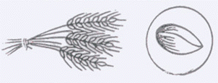
THE ORIGINAL GRAIN OF WHEAT THAT WAS PLANTED | "THE FIRST FRUITS"  THE GRAIN OF WHEAT THAT IS HARVESTED
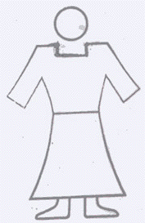 | 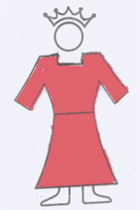
THE SON OF MAN(Math.16:16) | ONE LIKE THE SON OF MAN (Dan.7:13) THE SON OF MAN OF THE END TIME (Lk.17:26-30)
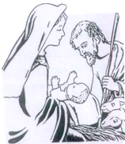 | 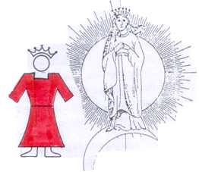
"Unto us A CHILD is born"  "You will find the BABE wrapped in swaddling clothes ,lying in a manger" -Lk.(2:12) | "Unto us A SON is given -Isaiah-9:6."She brought forth A MAN CHILD, who was to rule all nations with a rod of iron" - Rev.12:5
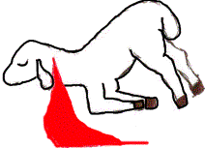
THE SLAIN LAMB | THE LAMB THAT LOOKED AS IF IT HAD BEEN SLAIN BECAUSE THE BLOOD OF THE SLAIN LAMB IS SPRINKLED UPON IT. ONLY THIS LAMB HAD RECEIVED THE SEALED BOOK(Rev.5) TO BREAK OPEN THE SEALS AND REVEAL THE MYSTERY OF GOD.
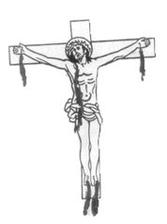
"Shall Messiah be cut off but not for Himself"- Daniel.9:26  Jesus Christ shed His Blood not for Himself ,but for man. | A man coming as THE KING OF KINGS and LORD OF LORDS with his vesture dipped in the blood of Jesus Christ. Rev.19:11-16

The HOLY BIBLE speaks of ONLY ONE LORD GOD. This only one LORD GOD has manifested. Himself as TWO MESSIAHS, to accomplish His TWO MINISTRIES in TWO DIFFERENT AGES, after a span of time of about 2000 years.

This one Lord God had come to the World 2000 years ago as Jesus Christ-THE ONLY BEGOTTEN SON, as the SAVIOUR (Jn. 3:16)

In these last days, at the harvest time, the same Lord God will visit the Church as THE CHRIST THE FIRST FRUITS OF THE HARVEST. As He is the first man RESTORED back TO THE CHRISTHOOD, the original status of Adam, He is called as THE FIRST BORN SON. He is the Son of man that was to come at this end time to accomplish the work of a REAL KINSMAN REDEEMER.- ( Matt. 24:32,33 ; Lk. 17:22,30)

Jesus Christ has only saved us, but not redeemed. And so, the REDEMPTION was yet to come at this end time. (Rom. 8:23)

Moreover, Jesus Christ was not our REAL KINSMAN. Though He was a man, He differs from us in His birth. He was born of the Holy Spirit ; but we are born of our parents. He was not of the human race. He had only saved us. To redeem us He wanted to become A REAL KINSMAN. That is why when He had promised of His second coming to the Church, He had said by a parable that He would come as THE MAN begotten by THE WOMAN THE CHURCH.

I tell you the TRUTH, unless a kernel of wheat falls to the ground and dies, it remains only a single seed. But if it dies, it produces MANY SEEDS Jn. 12:24.

One grain of wheat dies and produces many grains of wheat at the harvest time.

In the same way ONE SON OF GOD, had died to produce MANY SONS OF GOD being begotten by the woman, the Church at this harvest time the end of the world.

Out of these many Sons of God, the Lord had chosen the FIRST SON OF GOD to keep His name, and to manifest Himself as our REAL KINSMAN REDEEMER, and to fulfill His end time ministry.

The creation waits in eager expectation for the SONS OF GOD to be revealed - Rom. 8:19.

For those God foreknew He also predestinated to be conformed to the likeness of His Son, that he might be THE FIRST BORN among many brothers.- Rom. 8:29.

Thus the same Lord God, who had become Jesus Christ, THE ONLY BEGOTTEN SON has in these last days will manifest Himself as THE FIRST BORN SON-OUR REAL KINSMAN.

TWO DIFFERENT MINISTRIES OF ONE AND THE SAME LORD GOD!

THE SPIRIT of the Sovereign LORD is on me, because the LORD has anointed me to preach good news to the poor. He has sent me to bind up the broken hearted, to proclaim freedom for the captives and release for the prisoners.
TO PROCLAIM THE YEAR OF THE LORDS FAVOUR, AND THE DAY OF VENGEANCE OF OUR GOD Isa. 61:1,2.

THE FIRST MINISTRY ;

The first ministry of proclaiming the year of the LORDS favour was accomplished by Jesus Christ ; who had come as THE ONLY BEGOTTEN SON ( Jn. 3:16)

He went to Nazareth He went into the synagogue as was His custom, And he stood up to read. The Scroll of the prophet Isaiah was handed to Him. Unrolling it He found the place where it is written.

The Spirit of the Lord is on me, because He has anointed me to preach good news to the poor.
TO PROCLAIM THE YEAR OF THE LORDS FAVOUR"

Then He rolled up the Scroll, gave it back to the attendant and sat down. The eyes of everyone in the synagogue were fastened on Him, and be began by saying ; to them, today this Scripture is fulfilled in your hearing Luke. 4:16-21.

Jesus Christ while reading the above quoted Scripture : Isa. 61:1,2, He had read the first verse, and then while reading the second verse, He had read only the first part of the second verse, that is ;

TO PROCLAIM THE YEAR OF THE LORDS FAVOUR, and then He had stopped ABRUPTLY, and He did not read the latter portion ;

TO PROCLAIM THE DAY OF VENGEANCE OF OUR GOD.

So, it is quite evident that the latter part of ; to proclaim the day of vengeance of our God was yet to happen in the future.

Jesus Christ had brought the GRACE ( GODS FAVOUR) and that is why to announce it He had read the particular Scripture ; to proclaim the year of the Lords favour and stopped abruptly. From then onwards THE GRACE DISPENSATION had begun. The grace dispensation had been lasting until this harvest time, the end of the world.

At the end of the gentile dispensation God had to lift up His grace, and pour the judgment on the gentile world for rejecting. Jesus Christ. Before the pouring of the judgments the Lord God had to proclaim The day of vengeance of our God.

That is why the ANOINTING of the SAME SPIRIT OF THE LORD GOD that had proclaimed the year of the Lords favour has to come to the Church at this end time to proclaim the day of vengeance of our God.

And also the Lord Jesus Christ Himself has to come to the Church to break open the Seals in the Bible, and reveal the mystery of God (Rev. 10:1-7), and thus to transform the Bride. Because He only is the Lion of the tribe of Judah and the Root of David.

And I wept much, because no man was found worthy to open and to read the book, neither to look there on.

And one of the elders said unto me weep not : behold, the Lion of the tribe of Judha, the Root of David, has prevailed to open the book, and to loose the seven seals thereof. Rev. 5:1-5

Our citizenship is in heaven ; from where we look for the Saviour, the Lord Jesus Christ.

Who will change our vile body, that it may be fashioned like unto His glorious body,... Phil. 3:20,21.

The Lord Jesus Christ after His ascension had become the quickening Spirit.

The first man Adam became a living being ,the last Adam became a quickening Spirit
- I Corin. 15:45.

that he (Jesus) had come from God and was returning to God John. 13:3.

A little while, and you will not see me ; and again, a little while, and you will see me, BECAUSE I GO TO THE FATHER - John. 16:16

By these Scriptures it is quite evident that the Lord Jesus Christ after His ascension had gone back to the status of the Father, so to say that He will become THE SPIRIT again to fulfill the promise of His second coming to the Church.

1. To proclaim the day of vengeance of our God, and
2. To break open the Seals.

The Lord Jesus Christ, who will become the Quickening Spirit, has needed A BODY

A seed that was planted, at the harvest time it becomes the seeds again. In the same way the one Son of God that died for us, has become many Sons of God in the Church, by the Holy Spirit. The FIRST SON OF GOD that will attain the maturity is THE CHRIST THE FIRST FRUITS of the harvest, and He is called THE FIRST BORN SON, He will have the very same ANOINTING that was in Jesus Christ.

And thus THE ONE AND THE SAME LORD GOD will fulfill these two promises by THE FIRST BORN SON

1. He will proclaim the day of vengeance of God, by preaching the Message,INDICT TO THIS GENERATION
2. And He will break open the Seals in the Bible, and will reveal the mystery of God and thus has transformed the Bride into the FULLY MATURED GRAINS of the harvest. (like John of Patmos who was and is again to prophesy!!!!)

Till this harvest time, the end of the world, the Church had the revelation only about ONE MESSIAH, the Lord Jesus Christ, who had come as THE ONLY BEGOTTEN SON.

At the harvest time, one SEED that was planted produces many SEEDS. In the same way ONE SON OF GOD that died for us, had produced MANY SONS OF GOD in the Church, by the Holy Spirit, at this harvest time, the end of the world.

Now the harvest is almost over, and we see the grain of the first fruits, and other grains reproduced. ( Jn. 12:24)

The first fruits of the harvest refers to the MAN, who had first attained the maturity. He is the first man,who will be restored back to THE CHRISTHOOD, the original status of Adam He is called the FIRST BORN SON, the Lord has chosen this THE FIRST BORN SON to keep His name and to fulfill the promises of Jesus Christ for this end time.

1). Break opening of the Seals and revealing the mystery of God. ( Rev. 5 ; 10:1-7)

2). Proclaiming the day of vengeance of God.

Though the Apostle Paul had prophesied about the coming of the SONS OF GOD, and THE FIRST BORN SON, he had no revelation about these things as the harvest was yet to happen at this end time.

Now the harvest is about to start, and he see the promises in the Bible, and their fulfilments in the Church. We see THE CHRIST THE FIRST FRUITS OF THE HARVEST- THE FIRST BORN SON and His works in the Church.

1). Breaking of the Seals and revealing of the Mystery of God. And secondly.
2). Proclaiming the day of vengeance of our God.

Now the Lord explicitly revealing and showing in plain view, separating THE FIRST BORN SON-THE SECOND MESSIAH from THE ONLY BEGOTTEN SON the FIRST MESSIAH.

And that is why we ought to testify about the FIRST BORN SON, as the Apostle Paul had testified Jesus Christ as THE ONLY BEGOTTEN SON.

If the Apostle Paul were to be here at this harvest time, surely he would have testified, preached and proclaimed the very same Message what I have been testifying, preaching and proclaiming. And he would have done this more sternly and more emphatically.

The revelation about Jesus Christ, THE ONLY BEGOTTEN SON, has led the people into THE SALVATION. And now the revelation about THE FIRST BORN SON will lead the people into THE REDEMPTION.

SHADOWS AND TYPES IN THE BIBLE ABOUT THE TWO MESSIAHS

In the Holy Bible there are ample of shadows and types, and many prophecies to substantiate this fact about THE TWO MESSIAHS.

The people of Israel on the exodus in the wilderness represented the Church. In the wilderness, at two different places, two different rocks were smitten, on two different occasions, to get water.

TWO ROCKS

He split the ROCKS in the wilderness, and gave them drink in abundance like the depths. Psa. 78:15.

THE FIRST ROCK was at Horeb

Behold, I will stand before you there on the Rock in Horeb ; and you shall strike the rock, and water will come out of it Exo. 17:6.

THE SECOND ROCK was at Kadesh

Then Moses lifted his hand struck the Rock twice with his rod ; and water came out ABUNDANTLY
Numbers. 20:11.

At Horeb, when the first Rock was smitten it is written that water came out from the Rock. But at Kadesh, when the SECOND ROCK was smitten, it is written that the water came out abundantly.

The Lord had done this to set up a pattern or a shadow or a type of what He was going to do in the Church, the smiting of the TWO MESSIAHS in the Church, the FIRST MESSIAH at the beginning, and the SECOND MESSIAH at the ending of the Seven Church Ages.

THE FIRST SMITTEN ROCK refers to Jesus Christ THE ONLY BEGOTTEN SON. And the water that came out from the First Rock refers to the FORMER RAIN the Holy Spirit, that is only the first fruits of the Spirit. ( Rom. 8:23), the earnest of our inheritance ( Eph. 1:14)

That Spirit is the guarantee of inheritance the first fruit, the down payment on our heritage
- Eph. 1:14.

Jesus Christ, THE FIRST SMITTEN ROCK, had become THE CHIEF CORNER STONE of the Church
-( Eph.2:20)

You are built upon the foundation of the apostles and prophets with Christ Jesus Himself the Chief corner stone.

THE SECOND SMITTEN ROCK refers to THE CHRIST-THE FIRST FRUITS of the harvest, who is called THE FIRST BORN SON. (Rom. 8:39, Heb. 1:6)

The water that came out abundantly from the second smitten Rock refers to THE LATTER RAIN to impart THE FULNESS of the Spirit, that restores man to THE CHRISTHOOD, the original status of Adam. The restoration of CHRISTHOOD is OUR REDEMPTION.

The Christ-THE FIRST FRUITS of the harvest, that is THE SECOND SMITTEN Rock that was THE SON that was sent at the fruit season ( Matt. 21:33-44, Psa.118:22-26) And He has become THE CAPSTONE of the Church.

One Lord God had manifested Himself as THE ONLY BEGOTTEN SON, and had become THE CHIEF CORNER STONE, the beginning of the Church.

The same Lord God had manifested at this harvest time as THE FIRST BORN SON, and has become THE CAPSTONE of the Church, the ending of the Church.

Jesus Christ was the FIRST SMITTEN ROCK. And He was THE PASCAL LAMB that was offered at the beginning of the seven Church ages.

The Christ the FIRST FRUITS of the harvest is THE SECOND SMITTEN ROCK, and He is THE SACRIFICE OF ATONEMENT that was offered at the end of the Seven Church Ages.

THE SLAIN LAMB HAS BECOME THE LAMB THAT LOOKED AS IF IT HAD BEEN SLAIN.

Lord Jesus Christ has died to cleanse us from the stains of the sin, and to impart HIS DIVINE NATURE in to us.

In the Old testament times, when a man went to offer a sin offerings, at the alter he would lay his hands on the sin offering animal. Thus all his sins would be transformed on the animal, and then the animal would be sacrificed in the place of the sinner. The blood of the scarified animal would cover the sin, and the man would go being forgiven, but with the same unchanged nature, to commit the same sin again.

In the New testament age, when a sinner goes to Jesus Christ and confesses his sins to Him, all the sins would be transferred on Him, and all the sins would be forgiven. And the Lord would pour His Spirit into the man to IMPART THE DIVINE NATURE. Thus the Lord Himself would get into the saved man.

THE SLAIN LAMB HAS BECOME THE LAMB THAT LOOKED AS IF IT HAD BEEN SLAIN.

Now this is the greatest and the deepest mystery in the Bible. It is very much related to the Second coming of the Lord, how He would come.

Lord Jesus Christ is the SLAIN LAMB. He shed His blood and died for us. But the Lamb that went to receive the Sealed Book looked as if it had been slain, because the Blood of the slain Lamb had been sprinkled upon it. This Lamb that looked as if it had been slain refers only to a man who is saved by the sprinkling of the Blood of Jesus Christ.

When a man goes to Jesus Christ and confessed his sins, the Lord forgives his sins and cleanses him by sprinkling His Blood upon him. And then the Lord pours His Spirit into him to impart His divine nature. Thus Jesus Christ, Himself, who has become the Quickening Spirit, enters into the saved man and dwells in him. Now the Lord manifests Himself through this man.

At the harvest time, all the life and all the potentials that were in the seed that was planted, go and settle in the seeds reproduced. In the same way all THE ANOINTING and all THE POTENTIALS that are in Jesus Christ will come into THE CHRIST-THE FIRST FRUITS of the harvest, who is THE FIRST BORN SON.

That is how the same Lord God who had accomplished the works of the Saviour by THE ONLY BEGOTTEN SON, will accomplish the works of the kinsmen Redeemer by THE FIRST BORN SON, at this harvest time, the end of the world.

THE CHIEF CORNER STONE, and THE CAP STONE !

The Lord God always wants to be THE BEGINNING and THE ENDING ; THE FIRST and THE LAST.

The Lord God had become THE ONLY BEGOTTEN SON, and died for the Church to come up. He had laid Himself as the Chief corner stone.

You are built upon the foundation of the Apostles and prophets, with Christ Jesus Himself the Chief corner stone. Eph. 2:20.

And God has put all things under his feet and made him the supreme Head of the Church. Eph. 1:22.

Jesus Christ that died and became the CHIEF CORNER STONE, had become the Quickening Spirit, and had poured Himself into the Church. And at this harvest time the end of the world, He will AGAIN MANIFESTED Himself as THE CHRIST THE FIRST FRUITS of the harvest to become THE CAPSTONE OF THE CHURCH Matt. 21: 33-44

Whoever believed Jesus Christ, the first Smitten Rock, had become SAVED and were filled with the Holy Spirit, -the earnest of our inheritance. God had made them the priests (I. Pet . 2:5,9), and has placed them in THE HOLY PLACE of the Tabernacle.

Now, whoever believes the Christ, THE FIRST FRUITS, at the harvest the second smitten Rock become REDEEMED, being filled with all THE FULNESS OF GOD (Eph. 3:19), which is our inheritance. Now God will make them THE CHRISTS ( the grains of the harvest), and has led them into the HOLY OF HOLIES to be under Shekinah Glory. And God will give them THE ETERNAL NAME. This is the highest place that could be given to any man in the kingdom of heaven.

Only this little group of people, who will enter into THE HOLY OF HOLIES, will go in the Rapture, without passing through the death. Amen and Amen!

I will given them in my house, within my walls a name far greater than the honour they would receive from having sons and daughters. For the NAME that I will give them is AN EVERLASTING ONE ; it will never disappear. - Isa. 56:5.

SHADOWS, TYPES, AND PROPHECIES ABOUT THE SECOND MESSIAH ;

In the Holy Bible there are many shadows, types, and prophecies to confirm and substantiate the TRUTH about the SECOND MESSIAH. Even Apostle Paul had prophesied about the coming of the Sons of God, at this end time, and about the FIRST BORN SON. Till the harvest time, there was no chance for any man to have any revelation about the SECOND MESSIAH.

Only by the harvest, at this end time the Lord will raise the Sons of God, and this FIRST BORN SON, who is the SECOND MESSIAH.

Till this harvest time, all these shadows and types, and the prophecies ; all the people were thinking that all these things were referring only to Jesus Christ, who had come as the FIRST MESSIAH.

By the harvest of God at this end time, the Lord will raise THE FIRST BORN SON as the SECOND MESSIAH. And by Him various prophecies of Jesus Christ for the end time will be fulfilled in the Church.

As the Jews had missed the First Messiah that was sent to them, so the modern Christian world will miss this SECOND MESSIAH that was raised in the Church, at this harvest time, the end of the world.

Now the Lord is explicitly separating the prophecies, and clearly shows the SECOND MESSIAH in a very plain view, that nobody could deny the TRUTH.

The FIRST MESSIAH was that God Himself had become the Christ, and He was the God Messiah(King Messiah). At this end time, by the harvest, the Lord will restore man back to Christhood, and will raise the FIRST CHRIST reproduced by the Church, and will make Him the SECOND MESSIAH.

Jesus Christ, THE ONLY BEGOTTEN SON is the God Messiah(King Messiah), and the Christ THE FIRST FRUITS of the harvest is THE FIRST BORN SON, and He is THE MAN MESSIAH(Prince Messiah).

behold the MAN (the MESSIAH) whose name is THE BRANCH- Zec. 6:12( Amplified)

I am the Vine, you are the branches- Jn. 15:5

Jesus Christ is the Vine, and He is the God Messiah(King Messiah). He is THE FIRST MESSIAH. THE BRANCH is the MAN MESSIAH(Prince Messiah), and He is the SECOND MESSIAH.

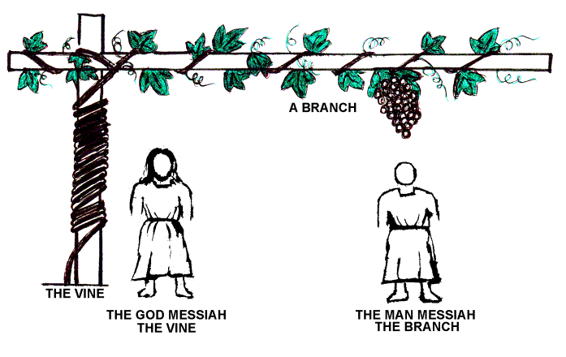
GOD MESSIAH THE WORD
AND
MAN MESSIAH THE WORD

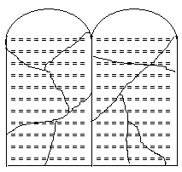 | 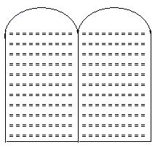
THE FIRST SET OF STONE TABLETS | THE SECOND SET OF STONE TABLETSs

THE FIRST SET OF STONE TABLETS ;

"Then Moses went down the mountain, holding in his hands the Ten Commandments written on both sides of two stone tablets.

The tablets were the work of God; the writing was the writing of God; engraved on the tablets
Exo. 32 ; 15,16.

The First set of stone tablets, which were made of God, and written of God, represents Jesus Christ, Who was born by God, and was made Christ by God.

The angel answered, The Holy Spirit will come upon you, and the power of the Most High will over shadow you. So the holy one to be born will be called the Son of God. - Lk. 1:35

Therefore I clearly state to everyone in Israel that God has made this Jesus you crucified, both Lord and Christ. Acts. 2:36.

This set of stone tablets, Moses had broken them into pieces (Exo.32:19). And those stone tablets could not be seen again.

This refers to Jesus Christ, who died for us. And after His ascension, He had become the Quickening Spirit. And He had poured Himself into the Church. And so, Jesus Christ cannot be seen anymore in the same Body.

THE SECOND SET OF STONE TABLETS:

The Lord said to Moses, Chisel out two stone tablets like the first ones, and I will write on them the Words that were on first tablets, which you broke Exo. 34:1.

The second set of stone tablets, which were MADE BY MAN and WRITTEN BY GOD. This represents THE MAN begotten by the woman THE CHURCH ( Jn. 16: 16-21 ; Rev. 12 : 1-5). This is the MAN MESSIAH, THE SECOND MESSIAH.

Only this second set of stone tablets which were made by man and written by God were kept in the ARK. And the Shekinah Glory was resting only on this second set of stone tablets, which were made by man and written by God.

Even in the eternity we are going to see this MAN MESSIAH.

THE TWO SMITTEN ROCKS, AND THE CHURCH

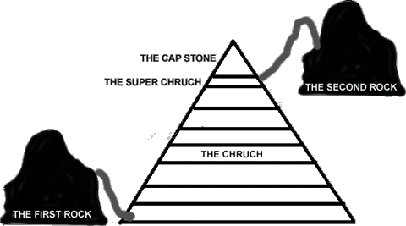

The people of Israel on their exodus to their promised land represented the Church. At two places, Horeb and Kadesh, two different Rocks were smitten to get water for the people. By these events, God was making a pattern or a shadow or a type to show how the two MESSIAHS would be smitten in the Church, at the beginning and at the ending of the Seven Church Ages to pour out the Holy Spirit, THE FORMER RAIN, and THE LATTER RAIN into the Church.

Be glad then, you children of Zion, and rejoice in the Lord, your God ; for He gives you the FORMER RAIN in just measure, and He causes to come down for you the rain, THE FORMER RAIN and THE LATTER RAIN as before. Joel. 2:23.

The first smitten Rock represents Jesus Christ, THE FIRST MESSIAH. And the water that came out of the first smitten Rock represents THE FORMER RAIN-the earnest of our inheritance ( Eph. 1:14). And by this former rain the people were led into SALVATION.

The Second smitten Rock represents THE SECOND MESSIAH-THE FIRST BORN SON-who is THE MAN MESSIAH, that will be smitten at the harvest time, the end of the world.

The abundant water that came out refers to THE FULNESS OF THE SPIRIT, Which is our INHERITANCE. This is THE LATTER RAIN that the Lord has pour on the TRUE BRIDE, at this end of the Laodicean Church Age.

Possessing the INHERITANCE IS THE REDEMPTION.

Only at this end time, a little flock at the top of the Laodicean Church age has received both the RAINS. The former RAIN has led the people into THE SALVATION. And THE LATTER RAIN has led the Bride into THE REDEMPTION.

Only this little flock which has received both the FORMER RAIN and the LATTER RAIN at this harvest time, the end of the world, will go in the Rapture without passing through the death. Amen and Amen !

THE TWO MESSIAHS ARE REPRESENTED BY THE TWO OLIVE TREES :

And the angel who talked with me came again, and awakened me, like a man who is wakened out of his sleep.
And said to me, what do you see? I said, I see, and behold, a lamp stand all of gold, with its bowl [ for oil ] on the top of it, and its seven lamps on it, and these are seven pipes to each of the seven lamps which are upon the top of it.
And there are TWO OLIVE TREES by it, one upon the right side of the bowl and the other upon the left side of it.
So I answered and spoke to the angel that talked with me, saying, what are these my lord?

Then said he, these are THE TWO ANOINTED ONES, that stand by the Lord of the Whole earth
- Zec. (4:1-3,14)
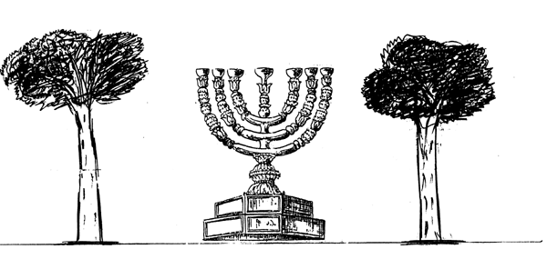

The mystery of the seven stars which you saw in my right hand, and the seven golden lamp stands : The Seven stars are the angels of the seven Churches, and the seven lamp stands which you saw are the seven churches. Rev. 1:20.

The Seven golden lamp stands represent the Seven Churches.

The two olive tress represent the two MESSIAHS THE TWO ROCKS by whom God had poured the Holy Spirit into the Church.

The first Olive tree represents Jesus Christ, THE FIRST MESSIAH THE FIRST SMITTEN ROCK. The Oil that the first Olive tree had poured into the Lamp Stand represents THE FORMER RAIN, Which is the earnest of our inheritance. And that has led us into SALVATION, and has made us the PRIESTS, and we were led into THE HOLY PLACE of the Tabernacle. (I. Pet. 2:5,9)

THE SECOND OLIVE TREE represents THE CHRIST the FIRST FRUITS of the harvest, which is the SECOND MESSIAH. And the Oil that goes forth from THE SECOND OLIVE TREE represents THE LATTER RAIN that is poured at the harvest time, the end of the world. It is OUR INHERITANCE. And it will lead us into REDEMPTION, and give us the status of the HIGH PRIEST-THE CHRIST. And that anointing will take us into the Holy of Holies, to be always under the SHEKINAH GLORY

PROPHECIES ABOUT THE BIRTH OF THE TWO MESSIAHS :

These are some Scriptures which have compound fulfillments and compound revelations;

Out of Egypt have I called my Son Hosea (11:1), Matt. 2:15.
...10...
This Scripture refers to the people of Israel coming out of Egypt ; and also to the event of bringing Jesus as a baby out of Egypt.

Behold, I will send you Elijah the prophet before the coming of the great and dreadful day of the LORD.

And he will turn the hearts of the fathers to their Children, and the hearts of the Children to their fathers; else I will come and strike the land with a curse. Mal. (4:5,6)

In this Scripture the first part of turning the hearts of the fathers to their children was fulfilled partly in the ministry of John the Baptist. ( Lk.1 : 16,17)

The latter part of turning the hearts of the children to their fathers is being fulfilled now at this end time, at the coming time of the Lord.

In the same way the prophecies about the birth of the two MESSIAHS have a compound fulfilments and are fulfiled in two different stages.

PROPHECY I

The Royal line of David will be cut off, chopped down, but from THE STUMP will grow A SHOOT Yes, A NEW BRANCH from the old root- Isa. 11:1( Living Bible)

FROM THE STUMP WILL GROW A SHOOTFROM THE OLD ROOT WILL GROW A NEW BRANCH

THE REVELATION OF A SCRIPTURE IS SEASONAL

God gives the revelation of a Scripture only at the ordained time. When God gives a prophecy, He Himself has got to interpret it. He is His own interpreter. God interprets His prophecy by bringing it to come to pass.

It is the principle of God that He always interprets the Scripture only after it is fulfilled.

Apostle John wrote the Book of Revelation. In the first three chapters, he has written about the seven churches in Asia minor. He looked at the conditions of every church and wrote his epistle. But he did not have the revelation that the Church would under go seven church ages for 2000 years, and in every church age the Church would be in the condition of the corresponding church that existed at that time. Only at the end of this Laodicean Church age, when all the Church ages have run out, the Lord has given us the revelation about the seven church ages. He shows the prophesies in the Bible, and connected them with their fulfillments in the history. That is how he has interpreted the seven church ages in general.

Jesus Christ, before His death, had told to His disciples about the prophecies about His death and resurrection.

Jesus took the twelve aside and told them, we are going to Jerusalem, and everything that is written by the prophets about the Son of man will be fulfilled. He will be handed over to the Gentiles. They will mock him, insult him, spit on him, flog him and kill him. On the third day he will rise again.

The disciples did not understand any of this. Its meaning was hidden from them, and they did not know what He was talking about. Lk. (18:31,34)

After His resurrection the Lord had told them the same Scriptures. Then they understood, because they saw the fulfillments of those Scriptures.

He said to them, This is what I told you while I was still with you ; Everything must be fulfilled that is written about me in the Law of Moses, the Prophets and the Psalms.

Then He opened their minds so they could understand the Scriptures. Lk. (24:44,45)

In the same way the prophecies about the birth of THE TWO MESSIAHS could not be revealed to the Church, though the first part of the Scripture. FROM THE STUMP OF JESSE WILL GROW A SHOOT was fulfilled in Jesus Christ 2000 years ago.

Only by the harvest of God, God will bring out THE CHRIST THE FIRST FRUITS of the harvest, who is THE BRANCH- THE SECOND MESSIAH.

And that is why the Lord very explicitly separates THE BRANCH THE SECOND MESSIAH from THE SHOOT THE FIRST MESSIAH that had come from THE STUMP OF JESSE. Only at this harvest time the end of the world, the Lord is revealing this Scripture and shows THE TWO MESSIAHS in a very plain view, which no man could dispute and deny.

FROM THE STUMP WILL GROW A SHOOT
"FROM THE OLD ROOT WILL GROW A NEW BRANCH"

This prophecy tells about how the Son of David would be born

THE SHOOT and THE BRANCH are two different parts of the same tree, and they are not the one and the same part.

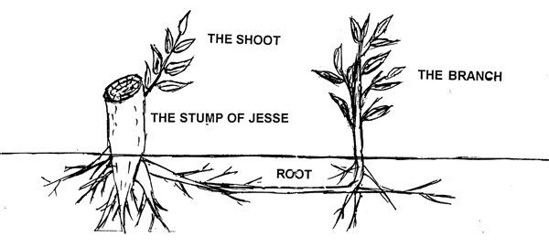

On the other hand THE SHOOT and THE BRANCH are two different OFFSPRINGS of the same tree, having the same LIFE.

Till this harvest time this Scripture of Isa. 11:1 was looked upon as if it had pertained only to Jesus Christ.

The one and the same Lord God had manifested Himself and will manifest Himself as TWO MESSIAHS, as THE SHOOT and THE BRANCH, in two different ages after a span of time of 2000 years.

The Lord God had first manifested as THE SHOOT at the beginning of the Church ages, and secondly will as THE BRANCH at the ending of the Church ages at the harvest time.

THE SHOOT represents Jesus Christ, THE FIRST MESSIAH(Messiah ben Judah), who had come from the direct lineage of David. Because THE SHOOT had come from THE STUMP of Jesse, its connection with the STUMP of Jesse is quite clear and visible. And so, no body will dispute this lineage of Jesus Christ from David.

And the latter part of the Scripture, from the old ROOT will grow a NEW BRANCH is now fulfilled only by the harvest of God at this end time, THE BRANCH refers to THE CHRIST THE FIRST FRUITS of the harvest. And He is THE FIRST BORN SON THE SECOND MESSIAH(Messiah ben Ephraim).

Now by the harvest, the Lord God will bring out THE BRANCH as THE FIRST FRUITS of the harvest. And now the Lord is revealing Him to Bride, explicitly separating THE BRANCH, and showing THE BRANCH distinctively different from THE SHOOT.

THE SHOOT had come from THE STUMP of Jesse, and its connection with the STUMP of Jesse is quite clear and visible. And so nobody will dispute the lineage of Jesus Christ from David.

Where as THE BRANCH had come out of a ROOT of the STUMP of Jesse. The root is completely concealed under the ground. So, the connection of THE BRANCH with the STUMP of Jesse is not open and clear.

THE BRANCH represents THE MAN MESSIAH, whose name is THE BRANCH. So, this MAN MESSIAH is a member of the Gentile Church, being brought forth as THE MAN CHILD by the women THE CHURCH. ( Jn. 16:16-21, Rev. 12:1-5)

The Gentile Church is THE REAL ISRAEL. (Rom. 2:28,29, Eph. 3:6). We are connected to the Abrahams lineage by Jesus Christ .(remember the real seeds or bloodline of Abraham,Isaac and Jacob shall be innumerable like the sand in the sea at the end days).

We are Abrahams SEED. For, we being dead in Christ, we take on Abrahams Seed, and are HEIR WITH HIM, under the same sworn promise

THE SHOOT represents Jesus Christ, THE ONLY BEGOTTEN SON-THE FIRST MESSIAH.

THE BRANCH represents THE MAN MESSIAH Whose name is THE BRANCH. He is THE CHRIST THE FIRST FRUITS of the harvest. He is THE MAN CHILD begotten by the women THE CHURCH (Jn. 16:16-21 ; Rev. 12:1-5). THE BRANCH IS THE SECOND MESSIAH, and He Himself is THE FIRST BORN SON.

